| CHARUSAT | CSPIT | Charusat University | Best Engineering College in Gujarat |
| --- | --- |

**Faculty of Technology and Engineering**

**Department of Computer Science and Engineering**

Date: 18/09/2024

**Event Application No in E-governance:** 2024-25/00284

**Event Name:** Session on “GITHUB and GITHUB Foundation certification journey under GrowWithGit” Club”

**Detail about the event:**

A session on GitHub and GitHub Foundation Certification Journey was conducted on 13th September 2024 for the students of the computer science department. The session aimed to introduce the students to the GitHub platform, its certification pathways, and the Microsoft Learn Student Ambassador (MLSA) program. The session was facilitated by Yatharth Chauhan, an esteemed alumnus of the university, who is the founder of Webxela, a GOLD Microsoft Learn Student Ambassador, and a 4X GitHub and LinkedIn certified professional. Yatharth’s extensive experience in these platforms provided valuable insights to the students on how to leverage GitHub certifications for their career growth and development.

The primary objective of the session was to familiarize students with:

* The GitHub platform and its potential for collaborative software development.
* The GitHub Foundation Certification process, outlining the steps students should take to earn certifications that are globally recognized.
* The Microsoft Learn Student Ambassador Program, an exclusive program that offers students the opportunity to connect with industry professionals, learn new skills, and showcase their expertise.

**Schedule of Event:**

| **Session No.** | **Session Date** | **Time** | **Expert name** | **Title** |
| --- | --- | --- | --- | --- |
| 1 | 13/09/2024 | 02:20 pm to 03:20 pm | Yatharth Chauhan, Founder Webxela | GITHUB and GITHUB Foundation certification journey |

**Resource persons**: Yatharth Chauhan, Founder Webxela, Microsoft Learn Student Ambassador (MLSA)

**Topic**: Session on “GITHUB and GITHUB Foundation certification journey”

**The event's outcome**: This session provided students with a clearer understanding of the certification process, the benefits of professional certifications, and how to make the most out of opportunities provided by platforms like GitHub and Microsoft.

**Actionable insights of Event:**

Through this event

1. Rubrics will be followed for Session

**Attach applicable Annexure:**

1. Brochure of the Event

3. Attendance

**Annexure-I**

**Brochure of the Event \***

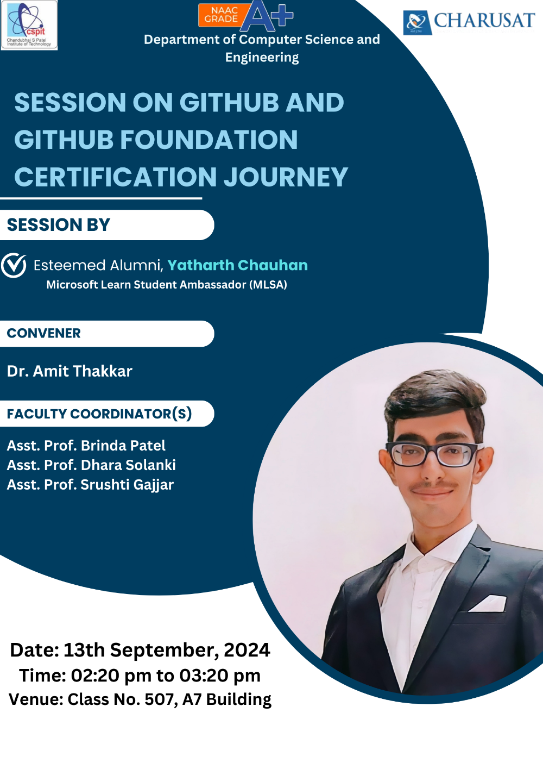

**Annexure-II**

**Attendees**

**Name of Session:** “Session on GITHUB and GITHUB Foundation certification journey”

**Date:** 13-09-2024

**Time**: 02:20 pm to 03:20 pm

**Venue**: Class No. 507, A7-CSPIT Building

| **Attendance** | | | |
| --- | --- | --- | --- |
| Sr. No. | ID No. | Name | Present/Absent |
| 1 | 22CS002 | ADITYA SUNIL POMAL | P |
| 2 | 22CS003 | AGHERA PRATHAM SAMIRBHAI | P |
| 3 | 22CS004 | ANDANI JAY RAMJIBHAI | P |
| 4 | 22CS005 | ANTALA HARSHILKUMAR MUKESHBHAI | P |
| 5 | 22CS006 | BABARIYA HASTI RAMESHCHANDRA | P |
| 6 | 22CS007 | BANUGARIYA NAND DHIRENBHAI | P |
| 7 | 22CS007 | BANUGARIYA NAND DHIRENBHAI | P |
| 8 | 22CS008 | BHAGAT JAY HITESH | P |
| 9 | 22CS009 | BHALANI VASU DINESHBHAI | P |
| 10 | 22CS011 | BORADA DAKSH JAGDISHBHAI | P |
| 11 | 22CS012 | BORDA PRIYANSIBEN PRAVINBHAI | P |
| 12 | 22CS013 | CASTELINO MELITA STEPHEN | P |
| 13 | 22CS014 | CHAUHAN VISHWAJITSINH SANJAYSINH | P |
| 14 | 22CS015 | CHHATROLA ARYANKUMAR MUKESHBHAI | P |
| 15 | 22CS016 | CHUDASAMA APURV PARESHBHAI | P |
| 16 | 22CS017 | DALSANIYA DRASHTI SHAILESHBHAI | P |
| 17 | 22CS019 | DESAI AART GIRISHCHANDRA | P |
| 18 | 22CS020 | DHOL SAMARTH CHETANKUMAR | P |
| 19 | 22CS022 | GAJIPARA NISHIT VRAJLAL | P |
| 20 | 22CS023 | GHODASARA MEET HARESHBHAI | P |
| 21 | 22CS027 | KANANI NISHANT DEVJIBHAI | P |
| 22 | 22CS028 | KANERIYA JAIMIN RAJESHBHAI | P |
| 23 | 22CS029 | KAR TRIPARNA JAYANTA | P |
| 24 | 22CS030 | KASUNDRA PIYU KAUSHIKKUMAR | P |
| 25 | 22CS033 | LAKKAD JAYRAJ SHANTILALBHAI | P |
| 26 | 22CS035 | MACWAN SHAIL SANJAY | P |
| 27 | 22CS036 | MAHALE DHRUVI MOHAN | P |
| 28 | 22CS038 | MANSURIYA AARAV PRAKASHBHAI | P |
| 29 | 22CS040 | MESHIYA RUCHIT DIPESHBHAI | P |
| 30 | 22CS041 | MISTRI AYUSH RAMESHBHAI | P |
| 31 | 22CS043 | NASIT YASH GHANSHYAMBHAI | P |
| 32 | 22CS044 | PANCHAL SHRUTI AMITKUMAR | P |
| 33 | 22CS045 | PAREKH JASH SUNILKUMAR | P |
| 34 | 22CS046 | PARMAR ABHISHEK NARENDRA | P |
| 35 | 22CS047 | PARMAR DHRUVIN SUNIL | P |
| 36 | 22CS048 | PARMAR JAYRAJSINH JAYSINH | P |
| 37 | 22CS049 | PATEL ANUJ KALPESHKUMAR | P |
| 38 | 22CS050 | PATEL BINDIYA SANJAYKUMAR | P |
| 39 | 22CS051 | PATEL DARSHKUMAR MANISHKUMAR | P |
| 40 | 22CS052 | PATEL DEV SANDIPKUMAR | P |
| 41 | 22CS053 | PATEL DHRUVI KIRANBHAI | P |
| 42 | 22CS054 | PATEL HARSH ALPESHBHAI | P |
| 43 | 22CS056 | PATEL KUNJ NIMISHKUMAR | P |
| 44 | 22CS058 | PATEL NISHARGKUMAR SUNILBHAI | P |
| 45 | 22CS059 | PATEL PRANAV MANSUKHBHAI | P |
| 46 | 22CS060 | PATEL PRANAV MUKESHKUMAR | P |
| 47 | 22CS061 | PATEL PRANSHAV DINESHKUMAR | P |
| 48 | 22CS062 | PATEL RISHI RAKESHKUMAR | P |
| 49 | 22CS064 | PATEL SHARAD KAPILBHAI | P |
| 50 | 22CS067 | PATEL VRAJ MILANKUMAR | P |
| 51 | 22CS068 | YASH SANJAYKUMAR PATEL | P |
| 52 | 22CS070 | PRAGTI BAVARVA | P |
| 53 | 22CS071 | PUROHIT RAHUL KETAN | P |
| 54 | 22CS072 | RAJKOTIYA DHARMIN MUKESHBHBAI | P |
| 55 | 22CS073 | ROKAD MIT LALJIBHAI | P |
| 56 | 22CS074 | RUPAPARA DHARMI DIPAKBHAI | P |
| 57 | 22CS075 | RUSHI JALPESHBHAI KARDANI | P |
| 58 | 22CS076 | SANTOKI KIRTAN SHILUBHAI | P |
| 59 | 22CS077 | SATANI PRINCE VIPULBHAI | P |
| 60 | 22CS080 | SHAH UTSAV BHUPESHBHAI | P |
| 61 | 22CS081 | SHAH VRAJ ATULKUMAR | P |
| 62 | 22CS083 | TADHANI PRINCE ARVINDBHAI | P |
| 63 | 22CS084 | TALPADA MONARK NAVINBHAI | P |
| 64 | 22CS085 | PARAM THAKKAR | P |
| 65 | 22CS087 | VAGHELA KAVANKUMAR JITENDRABHAI | P |
| 66 | 22CS088 | VAGHELA ROHAN KISHORBHAI | P |
| 67 | 22CS089 | VAISHNANI DARSH SAILESHBHAI | P |
| 68 | 22CS090 | VASHI PARVA ALKESHKUMAR | P |
| 69 | 22CS091 | VEKARIYA SHREYA NARESHBHAI | P |
| 70 | 22CS092 | VEKARIYA SUJAL NARESHBHAI | P |
| 71 | 22CS093 | VIRANI PARTH KISHORBHAI | P |
| 72 | 22CS095 | ZALA KARAN VIJAYBHAI | P |
| 73 | D23CS096 | SURIYA RENISH MUKESHBHAI | P |
| 74 | D23CS097 | PATEL KUNJ DIPAKBHAI | P |
| 75 | D23CS098 | ZALA ANJANABA HARDEVSINH | P |
| 76 | D23CS100 | CHAUHAN PRIYANSHI SANDIPKUMAR | P |
| 77 | D23CS102 | KALE SIDDHIT JITENDRAKUMAR | P |
| 78 | D23CS103 | MAKWANA PARTHIV RAMESHBHAI | P |
| 79 | D23CS104 | RUPAREL DENIS KALPESHKUMAR | P |
| 80 | D23CS105 | SHUBHAM SUMANT | P |
| 81 | D23CS107 | MEHTA KATHAN ROHITBHAI | P |
| 82 | D23CS108 | MAHALE TANAY DIPAKBHAI | P |

***Photographs with Caption***

|  |
| --- |
| **Photo of Session (Date: 13/09/2024)** |
|  |
| **Photo Session (Date: 13/09/2024)** |

|  |
| --- |
| **Photo of Session (Date: 13/09/2024)** |